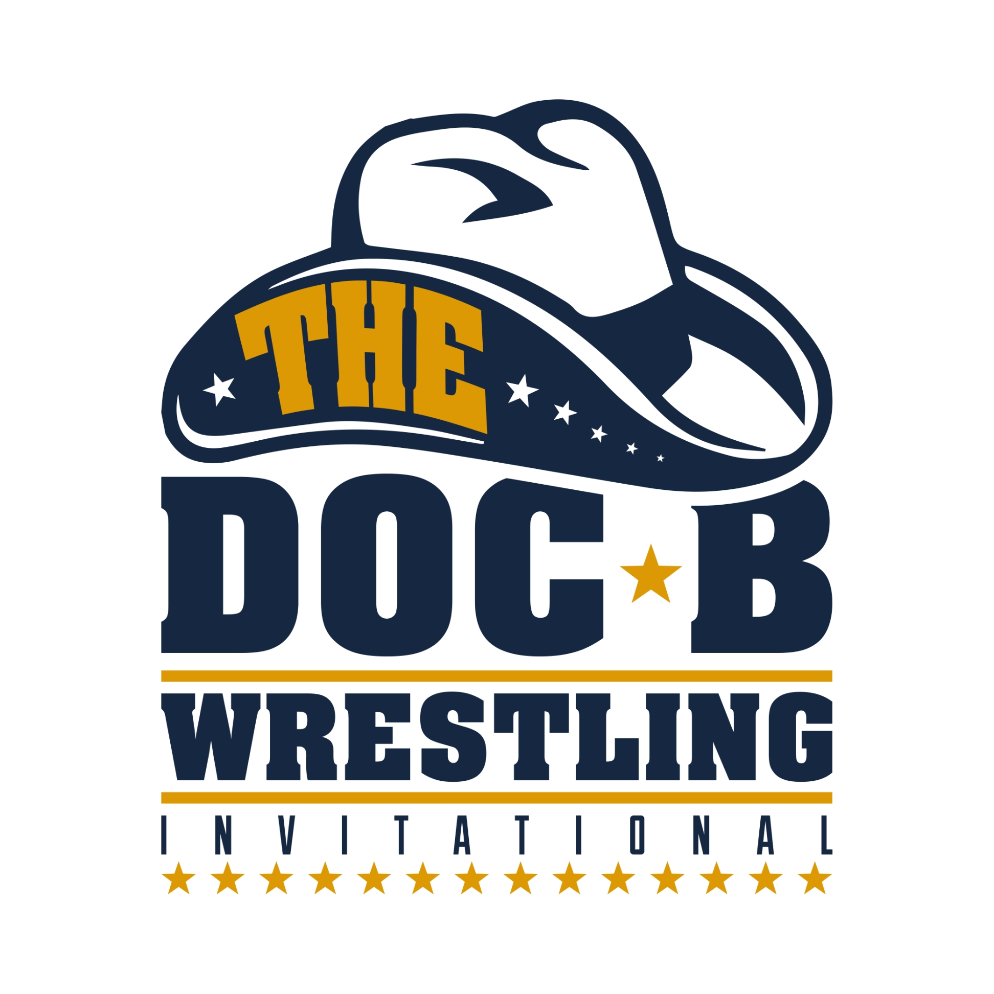
This agreement is between Clovis High School and participating schools regarding ‘The Doc B” entry for January 9 and 10, 2026 at Clovis High School, Clovis, California. The Doc B is a California and NFHS sanctioned tournament and all CIF (California Interscholastic Federation) rules apply. The Doc B is a showcase event for high school wrestling’s most accomplished wrestlers. To enter, your wrestler(s) must meet the criteria listed below. Once Mike Noel, our Assistant Athletic Director, receives your contract, Mike will email entry confirmation. All team login registration information will be emailed to you in December to register wrestlers.
ENTRY FEE
Individual entry fee of $100 per wrestler (9 or fewer wrestlers registered)

Team entry fee of $1000 per team (10 or more wrestlers participating)

ONCE WE REACH CAPACITY, WRESTLERS WILL BE PUT ON A WAITING LIST, SO PLEASE RETURN YOUR CONTRACT ASAP

REGISTRATION CRITERIA

Only wrestlers who meet the registration criteria listed below will be allocated slots. Out-of state teams are asked to bring ONLY competitive wrestlers, usually a returning state medalist. More than 7 wrestlers require prior approval from Tournament Directors. Demand is higher than ever and slots have to be allocated accordingly. For California schools, the following criteria must be followed:

1. Previous California State qualifier
2. Current Top 20 California state ranking

WRESTLERS NOT MEETING ANY OF THESE CRITERIA WILL BE PLACED ON A WAITING LIST

PARTICIPATING SCHOOL INFORMATION

School____________________________________ Head Coach_______________________________

Cell Phone____________________________ E-mail Address __________________________________

It is understood that there will be no refund for wrestlers who are registered and do not meet the above criteria or wrestlers who are registered but end up not wrestling at the tournament.

Principal or Athletic Director __________________________________ Date _____________

Mail completed contract with entry fee to Clovis High School, Attn: Mike Noel, 1055 Fowler, Clovis CA 93611 or email mikenoel@cusd.com

